About York College
News

Museum meets giving challenge for $200,000 boost
Houston, Chrystal posted on 9/12/2014 4:58:00 PM
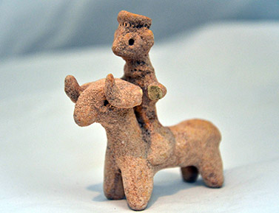
The Museum of Ancient History at York College has reached an important milestone: a $100,000 challenge gift from museum founder C. Foster Stanback has been met. The resulting $200,000 will provide display cases, moveable walls, signage, climate-controlled storage, ambient control, security features, operational costs, and other items needed before the museum can open.
The museum is now preparing for a grand opening in spring 2015.
The challenge was completed when the York County Visitor’s Bureau board approved a $40,000 improvement grant for the project.
“The Visitor’s Bureau board realizes the impact that this museum will have on not only the college, but also the community,” says Bob Sautter, executive director of the visitor’s bureau. “This will be a world-class collection. You won’t find anything like it anywhere else in the Midwest. We’re really excited about it and feel fortunate that we can support a museum that is going to be a tremendous asset to our county.”
“The museum will bring a whole new group of visitors to York,” says Sautter, noting that York has several other historical attractions that focus on more modern history. “Soon visitors will be able to enjoy a whole day of experiencing history in York, Nebraska.”
Museum curator Amber Soderholm says that the additional funding will also contribute to exhibit components including LED track lighting, videos, custom-made mounts for objects, and replicas for comparison purposes. It will also enable other exhibit enhancements, including painted murals, informational text panels, and graphics. "This funding will provide environmental HOBO monitors for tracking temperature and humidity to understand and adjust the museum environment to proactively preserve the artifacts," she says.
About the Museum of Ancient History
The Museum of Ancient History was established at York College in 2014 with a gift from private antiquities collector C. Foster Stanback. The collection currently has 230 pieces that span from the Neolithic Period (6500-3500 B.C.) to the 17th century A.D. A large portion of the collection is comprised of artifacts focused on the ancient Roman soldier including military diplomas, decorative medals, rings, clothing, seals, armor and weapons.

